PHP Tutorial – using phpMyAdmin and querying databases

In this tutorial, we are going to look at how to use phpMyAdmin to set-up a database table on the newnumyspace web server and at how to query the contents of the table using a php script. Before doing this tutorial, you should have done the newnumyspace, forms, and the previous PHP tutorials.

Task 1: Accessing your database using phpMyAdmin

In this exercise, you are going to use phpMyAdmin to access your database (which has been set-up for you) on your account on the newnumyspace web server via a web based interface. The database type used with the newnumyspace web server is MySQL.

- Open a new browser window and enter the following web address: http://phpmyadmin.newnumyspace.co.uk/

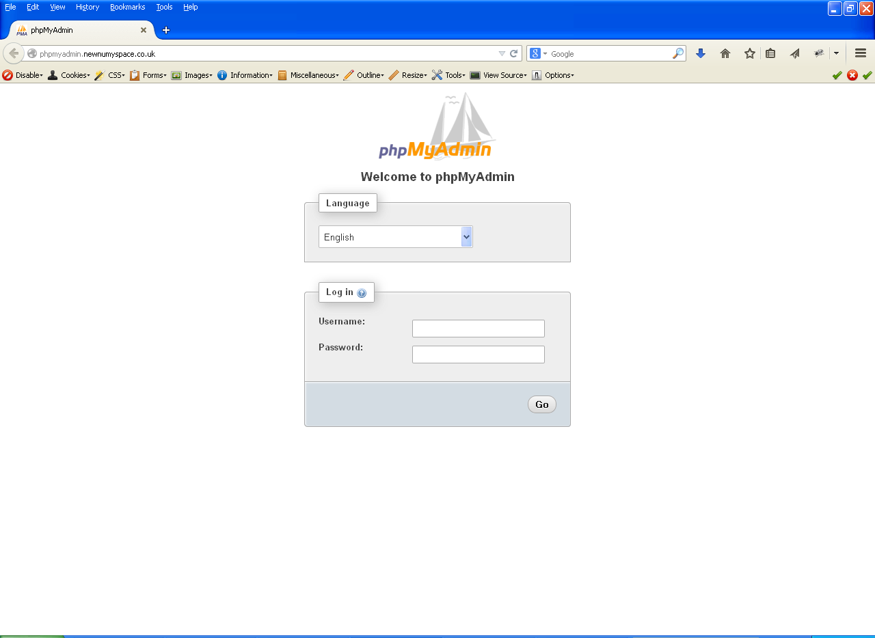

- Using the web page that is displayed, enter the same username and password that you use for the newnumyspace web server and click Go. A window like the following should be displayed:

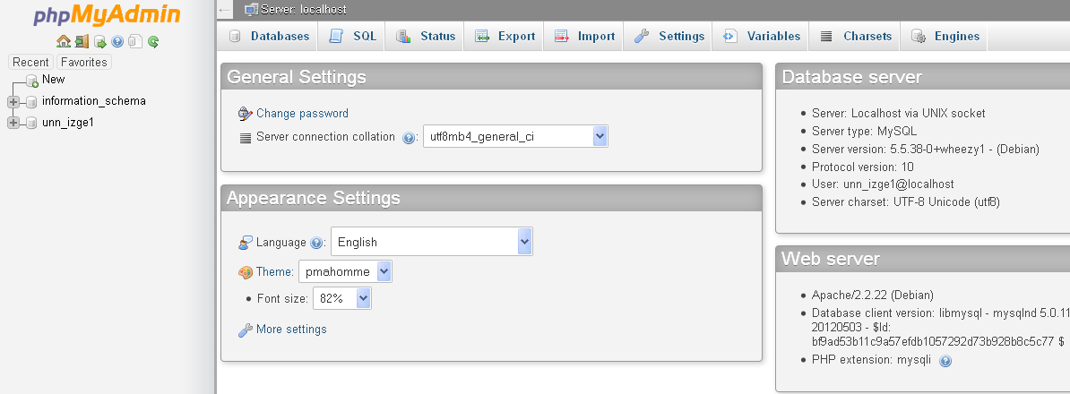

- There should already be a database with the same name as your username (e.g. unn_izge1). Click on it to select this database. You should see a screen something like the following:
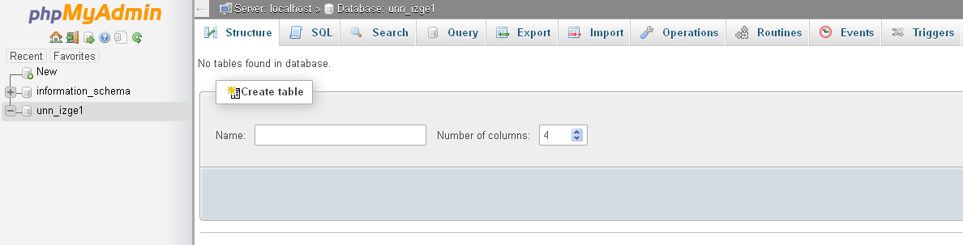

This interface provides features that allow you to create new tables (then add records etc.), and to do SQL queries on tables, import sql files etc. if you want to.

Exercise 2: Creating and viewing a table in the database

We are now going to import a .sql file that has already been created for you into phpMyAdmin that contains code to create two tables, called film and film_category, and to populate them with some records to set up tables and records for use in this workshop containing details of a range of films. Note that while you could create this by hand using the phpMyAdmin interface it will be quicker to do it using the file provided. You could perhaps experiment with creating tables by hand after you have finished the workshop if you want to.

- From the E-learning portal (Blackboard) download the file film.sql and save it to your u drive

Creating a database table and adding records to it

- In the phpMyAdmin interface make sure that you have clicked the database name (which is the same as your username) to select it, then click on the Import tab
- Click on the Browse button and then navigate to and select the file film.sql that you just downloaded
- Click the Go button at the bottom right of the screen. The SQL code in the film.sql should execute and you should see a confirmation like the following

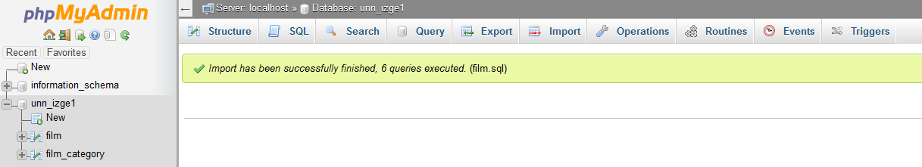
Database name
Import tab

If you look in the column on the left of the screen you should see that a new tables called ‘film’ and ‘film_category’ have been added to your database.

Seeing the structure and records of the tables you have added to the database

- Click on the name of the film table that you created in the column to the left. By default, this will show you the details of the film records that were added to the table. The first five records displayed will look like:

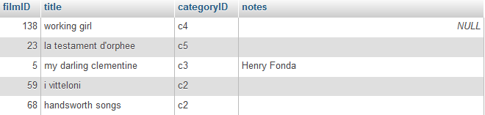

Note that by default up to 25 records are displayed at a time. You can choose to change the number displayed by selecting a different number in the box next to the Number of rows: button or by clicking Show all.

- Click on the Structure tab to display details of the film table’s fields
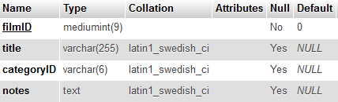

Clicking on the Browse tab would take you back to the view that shows the details of the records.

- Click on the name of the film_category table. It will contain film categories
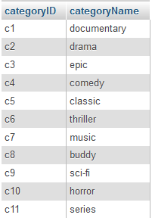

- Click on the Structure tab to display details of the film_category table’s fields

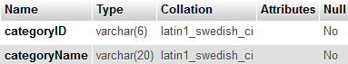

In the following exercises remember that you will then need to upload copies of each file you create onto your web space on the newnumyspace web server and that to test them you need to enter the appropriate web address into the address bar of your web browser.

Exercise 3: Making a re-usable database connection script

In this exercise we will create a re-usable script (for this workshop and subsequent ones) to make a connection to your MySQL database on the newnumypsace web server.

- Enter/copy the php code given below into a new php script and give it the filename database_conn.php

<?php
$dbConn = new mysqli('localhost', 'username', 'password', 'databaseName');
if ($dbConn->connect_error) {
echo "<p>Connection failed: ".$dbConn->connect_error."</p>\n";
exit;
}
?>

- Change the username and the password to your newnumyspace username and password, and the databaseName to your username (as they are the same thing for you)

Note that the code in this script will be imported (‘included’) in other scripts that will have their own doctype tags etc., so we do not need to include these in this script.

Exercise 4: Querying the film database table using PHP
- Enter/copy the code provided below into a new PHP script at an appropriate point (remembering to use the basic HTML5 core tags as a basis). Save it as filmQuery.php into the same location on newnumyspace that you saved the database_conn.php script.

<?php
include 'database_conn.php'; // make db connection

$sql = "SELECT filmID, title, notes FROM film";
$queryResult = $dbConn->query($sql);

// Check for and handle query failure
if($queryResult === false) {
echo "<p>Query failed: ".$dbConn->error."</p>\n</body>\n</html>";
exit;
}
// Otherwise fetch all the rows returned by the query one by one
else {
while($rowObj = $queryResult->fetch_object()){
echo "<div>{$rowObj->filmID}, {$rowObj->title}, {$rowObj->notes}</div>";
}
}
$queryResult->close();
$dbConn->close();
?>
This code will
- Connect to the database using the re-usable script that you created in exercise 3
- Query the database to retrieve each record held in the ‘film’ table of the database that you set-up earlier
- Output to the web browser one div containing the filmID, title and film notes (separated by a comma) for each film (i.e. each record) in the film table. The output displayed should look something like:
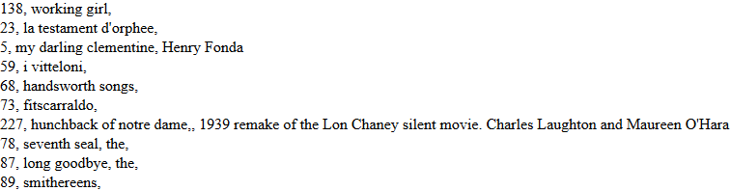
- In the web browser, choose the option to view the source. You should notice that each div it is not displayed neatly on separate ‘lines’ as it is in the normal browser window view. This is because the <div> elements separate the ‘lines’ in the browser window, but nothing at the moment is formatting the source code.

Now add ‘\n’ at an appropriate place in the php echo statement to add new line characters in the source to format it a little better.

Exercise 5: querying the film and the film_category table
If we want to display the category name, we need to join the film and film_category tables on the field (column) that is common between them, categoryID. This will allow us to get the category names from the film_category table that match the category IDs stored in the film table.

- To display the category name modify your php script as follows:
  - Change the $sql variable to
$sql = "SELECT filmID, title, categoryName, notes
FROM film
INNER JOIN film_category
ON film_category.categoryID = film.categoryID";

  - Change the line of code that reads

echo "<div>{$rowObj->filmID}, {$rowObj->title}, {$rowObj->notes}</div>";

to include {$rowObj->categoryName}, before {$rowObj->notes}

The output displayed should now look something like:
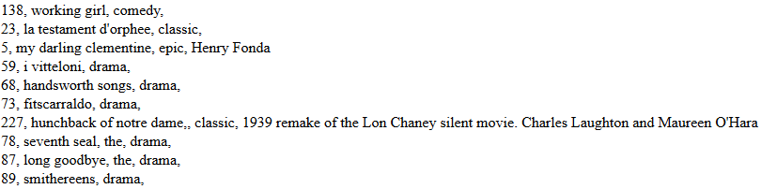

Exercise 6: Changing the presentation of the query
At the moment, the output that the user sees in the web browser is not particularly well formatted. In this task, you will improve that by first ordering the films by title and then by adding some CSS hooks (in this case class names) to the html that is generated by the script, and then apply CSS to those to improve the appearance of the output in the browser.
- Firstly, modify the SQL in your code so that the listing is ordered by title. You should always try to make the data easy for the user to look at.
- Modify the PHP script created in exercise 4 to remove the commas between the record details and to add CSS class names in appropriate places. Each div generated by the script should now contain html like the following:

<div class='film'>
<span class='filmID'>5</span>
<span class='title'>my darling clementine</span>
<span class='category'>epic</span>
<span class='notes'>Henry Fonda</span>
</div>

The output displayed should look something like the following at the moment. Not much different, except for the absence of commas and ordering by title. However, if you choose the option to view the source in the web browser, you should see a difference in the html structure.

- Create a CSS file with appropriate classes to format the display of the content by
- Adding more vertical space between each article so that they are spaced out a little more
- Applying an appropriate font type and text size (plus colours if you wish)
- Adding more horizontal space between each record detail (e.g. between its filmID, title ….) to give the appearance of the records being displayed in columns (hint: margin, or padding, or flex perhaps)
- Add html to the head area of the script to link to your new css file and test your php script. The output displayed could now look something like
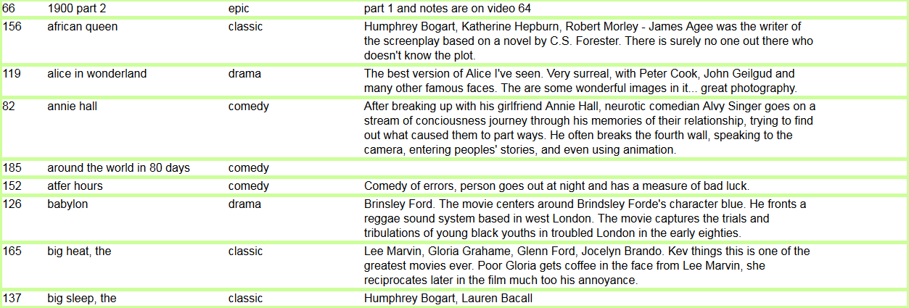

Directed learning challenge – validation errors

If you have time in the workshop attempt this challenge, otherwise attempt it as directed learning.
HTML validation

Remember that all web pages (whether .html files or ones with output generated by PHP) must use an HTML5 doctype and a utf-8 charset. In addition, all of the html syntax of the page must be checked and must pass validation without errors or warnings.

- Check your page using the validator and if you find any errors, correct them

